**Jfrog using Docker Assignment**

1. Install jfrog artifactory from docker using the commands:

“docker pull docker.bintray.io/jfrog/artifactory-oss:latest”

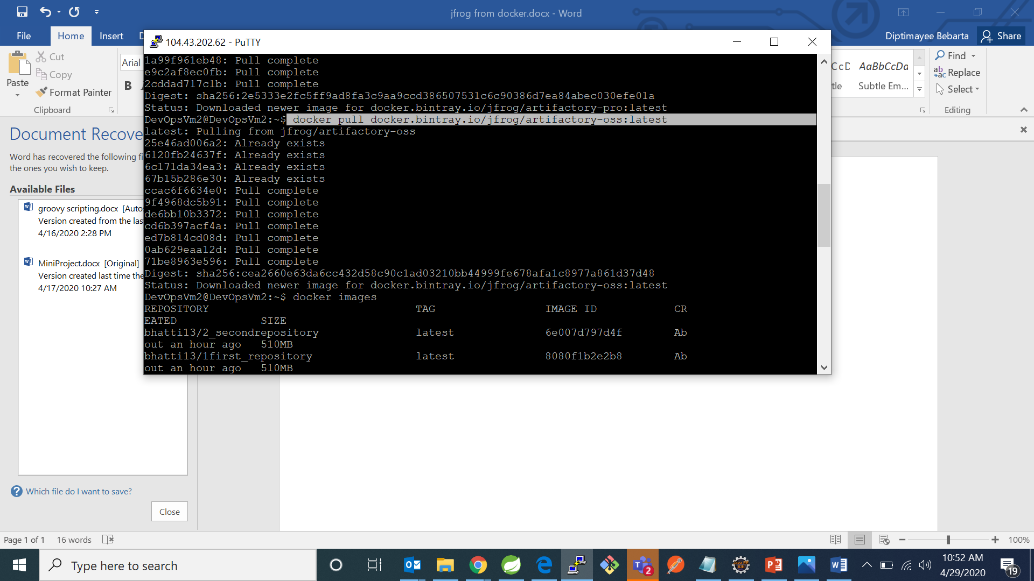

1. Now check if the docker image of artifactory is downloaded or not by using command “docker images”

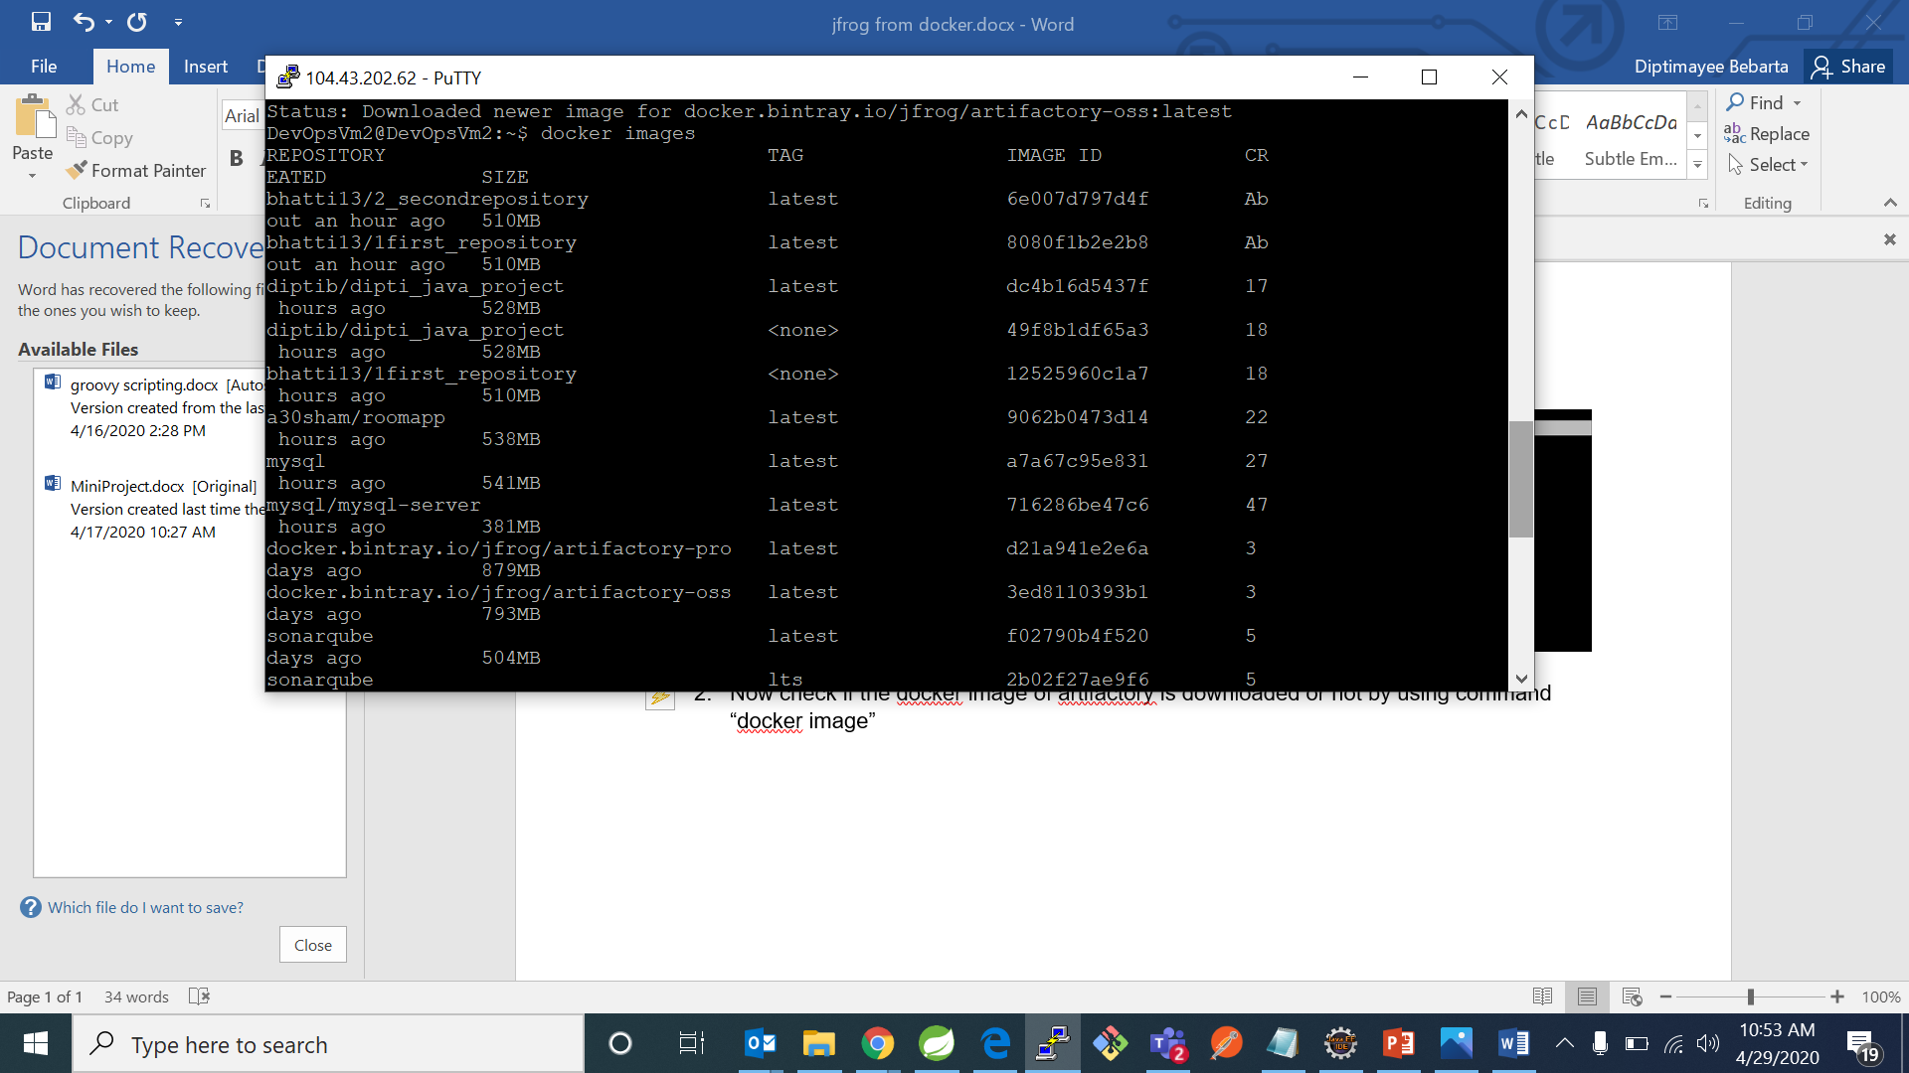

1. Now to run jfrog artifactory on port 8082 use command:

”docker run --name artifactory -d -p 8082:8082 docker.bintray. io/jfrog/artifactory-oss:latest”

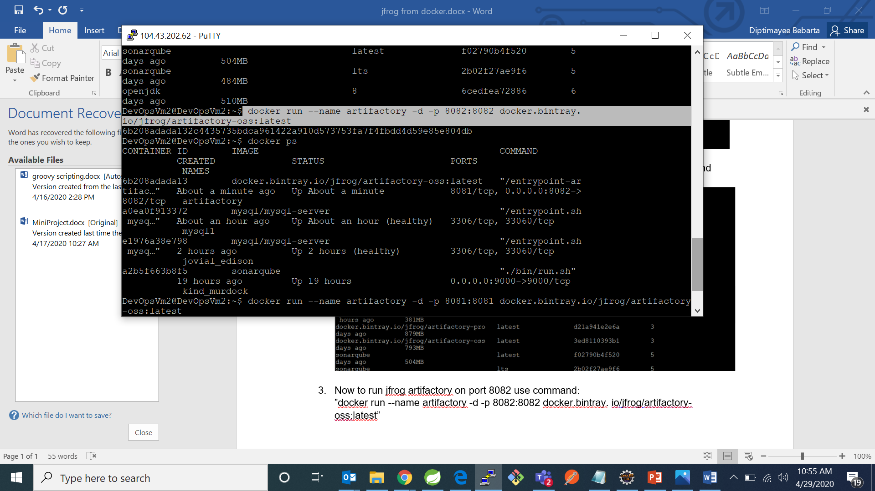

1. Now check for running containers by using command :”docker ps”

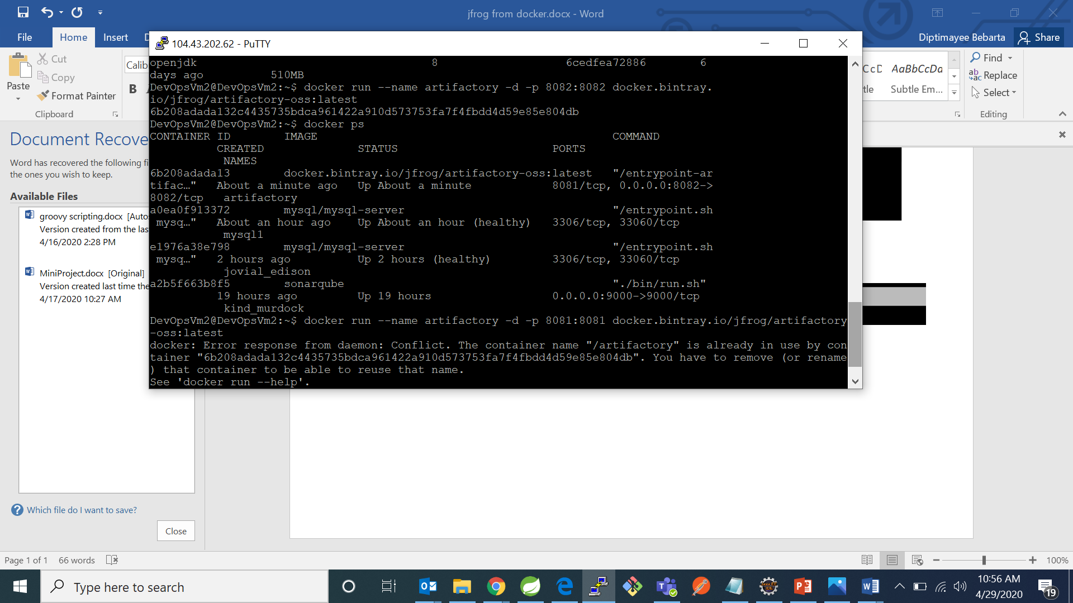

**TO BUILD AND STORE YOUR PACKAGE IN JFROG ARTIFACTORY:**

* First we have to go to manage jenkins and click on manage plugins

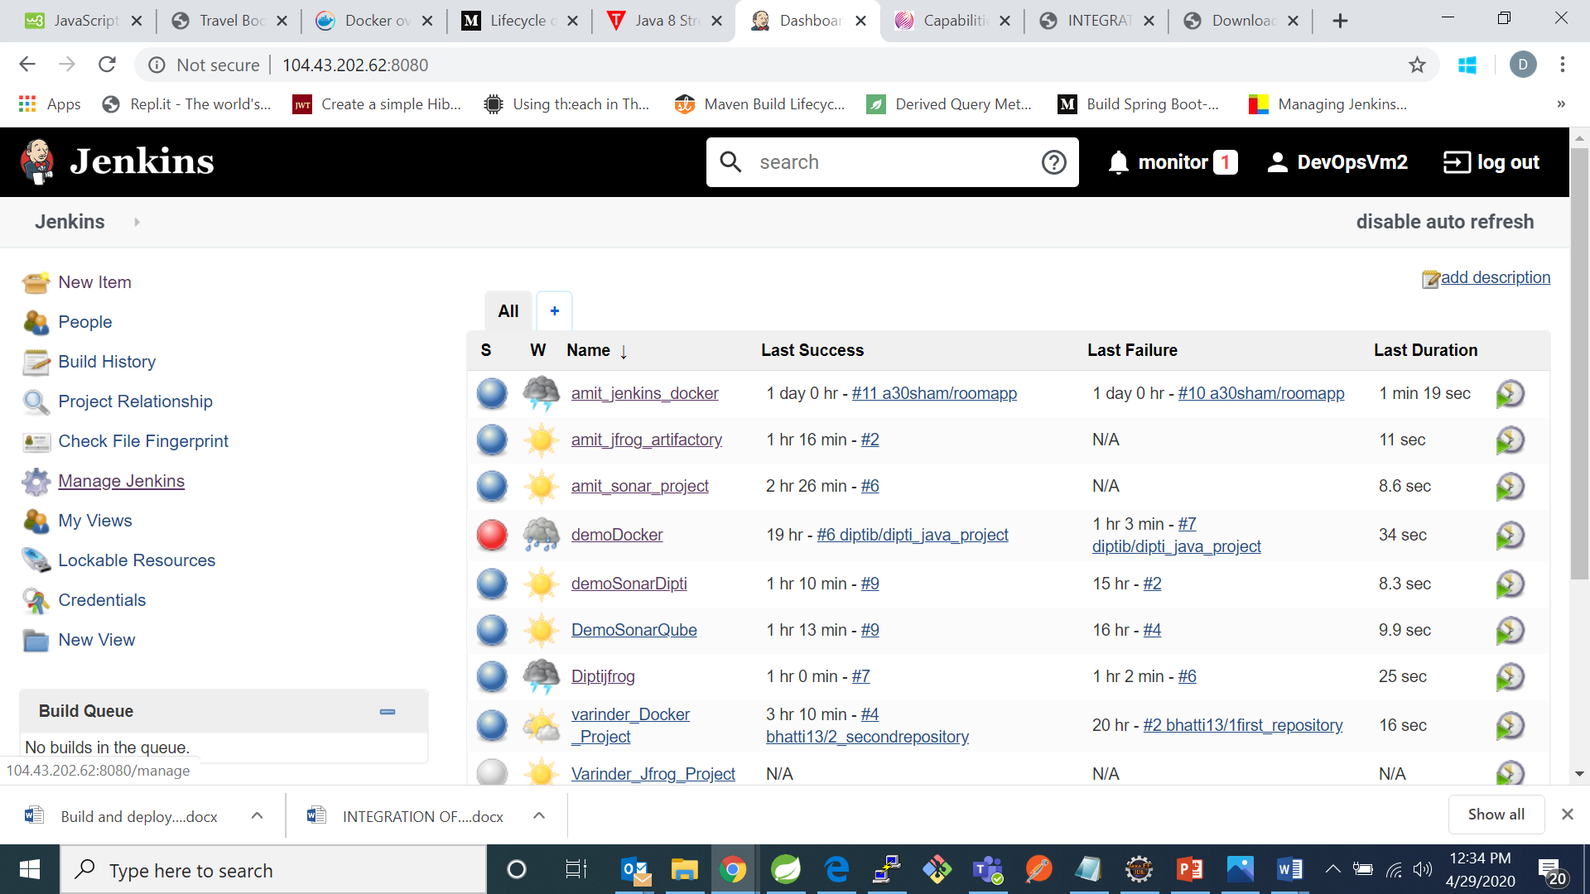

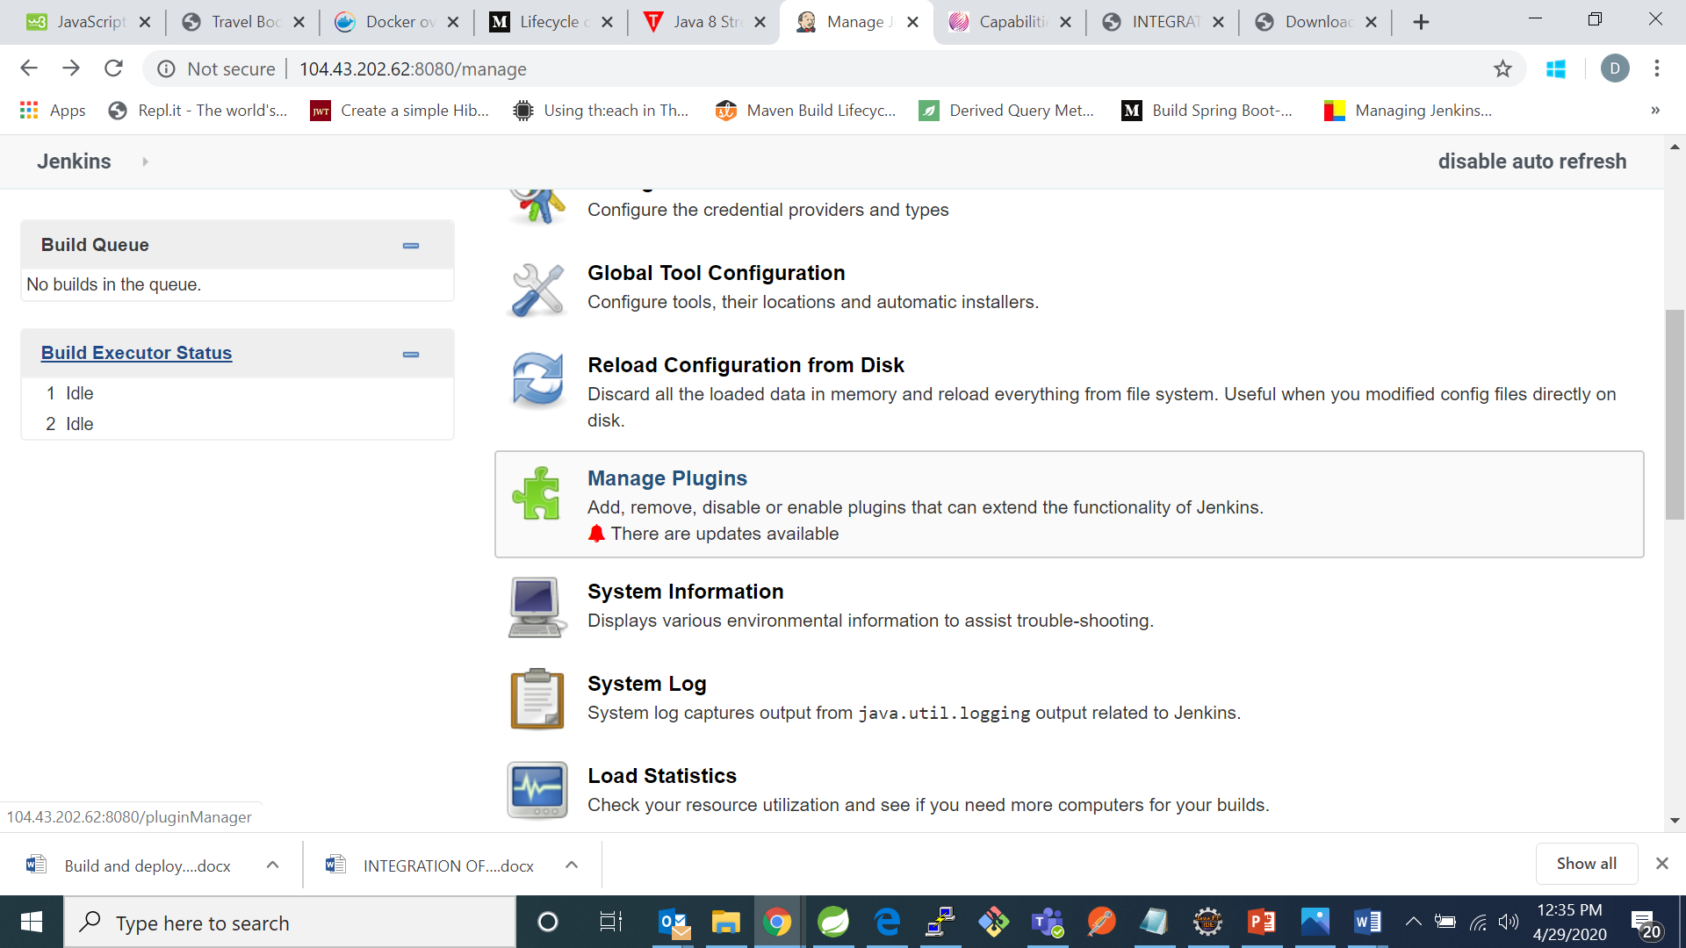

* Before that you have to do some configurations got to manage jenkins and click on configure system and then go to artifactory server and give name, url and credentials like shown below

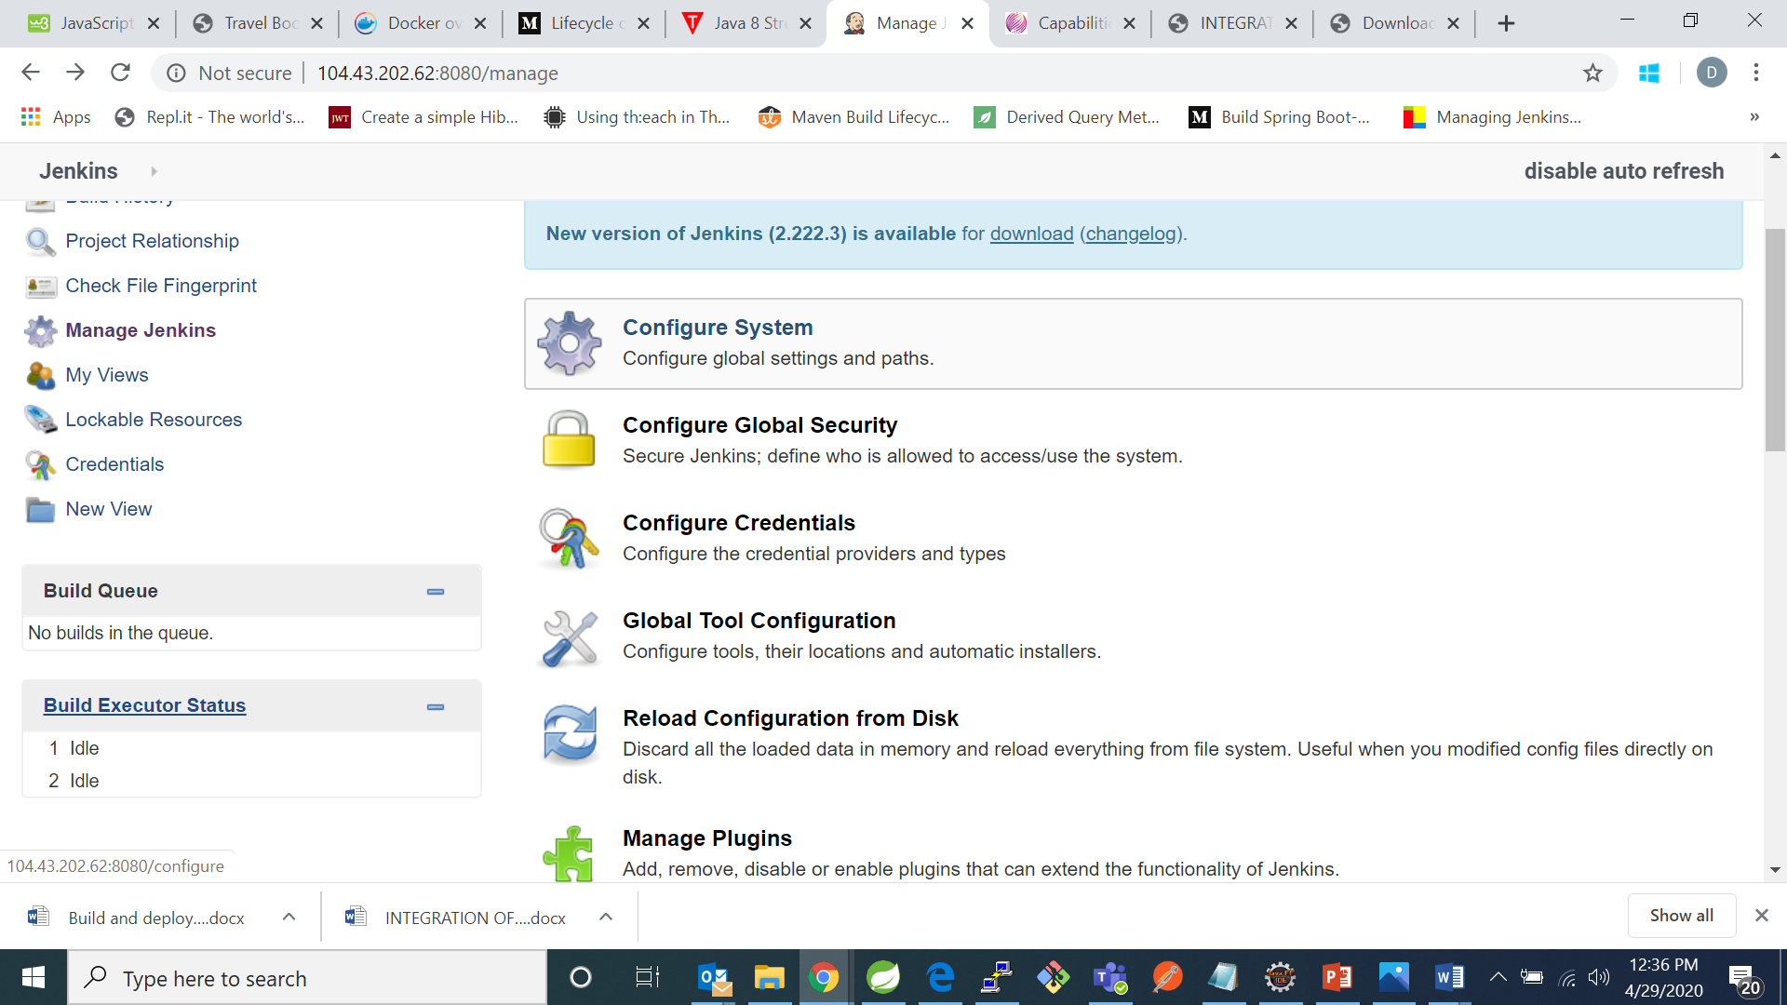

* Now got to artifactory and fill the details

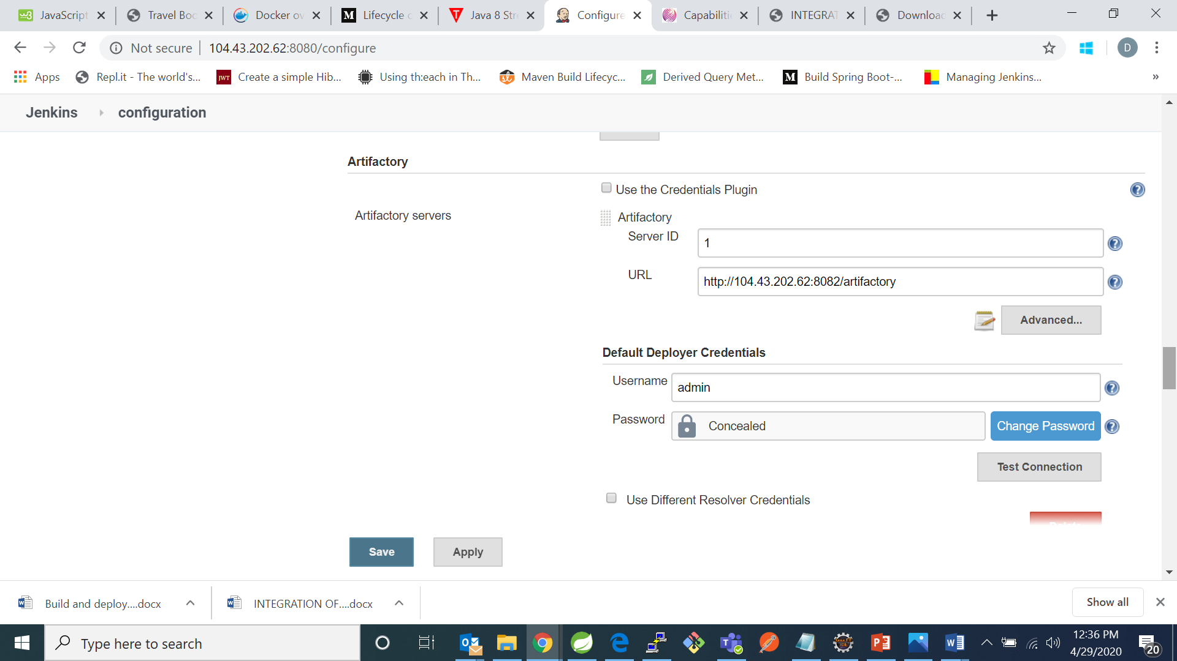

* In next step we have search for artifactory plugin in available tab in my case I have already installed that so I found it in installed tab

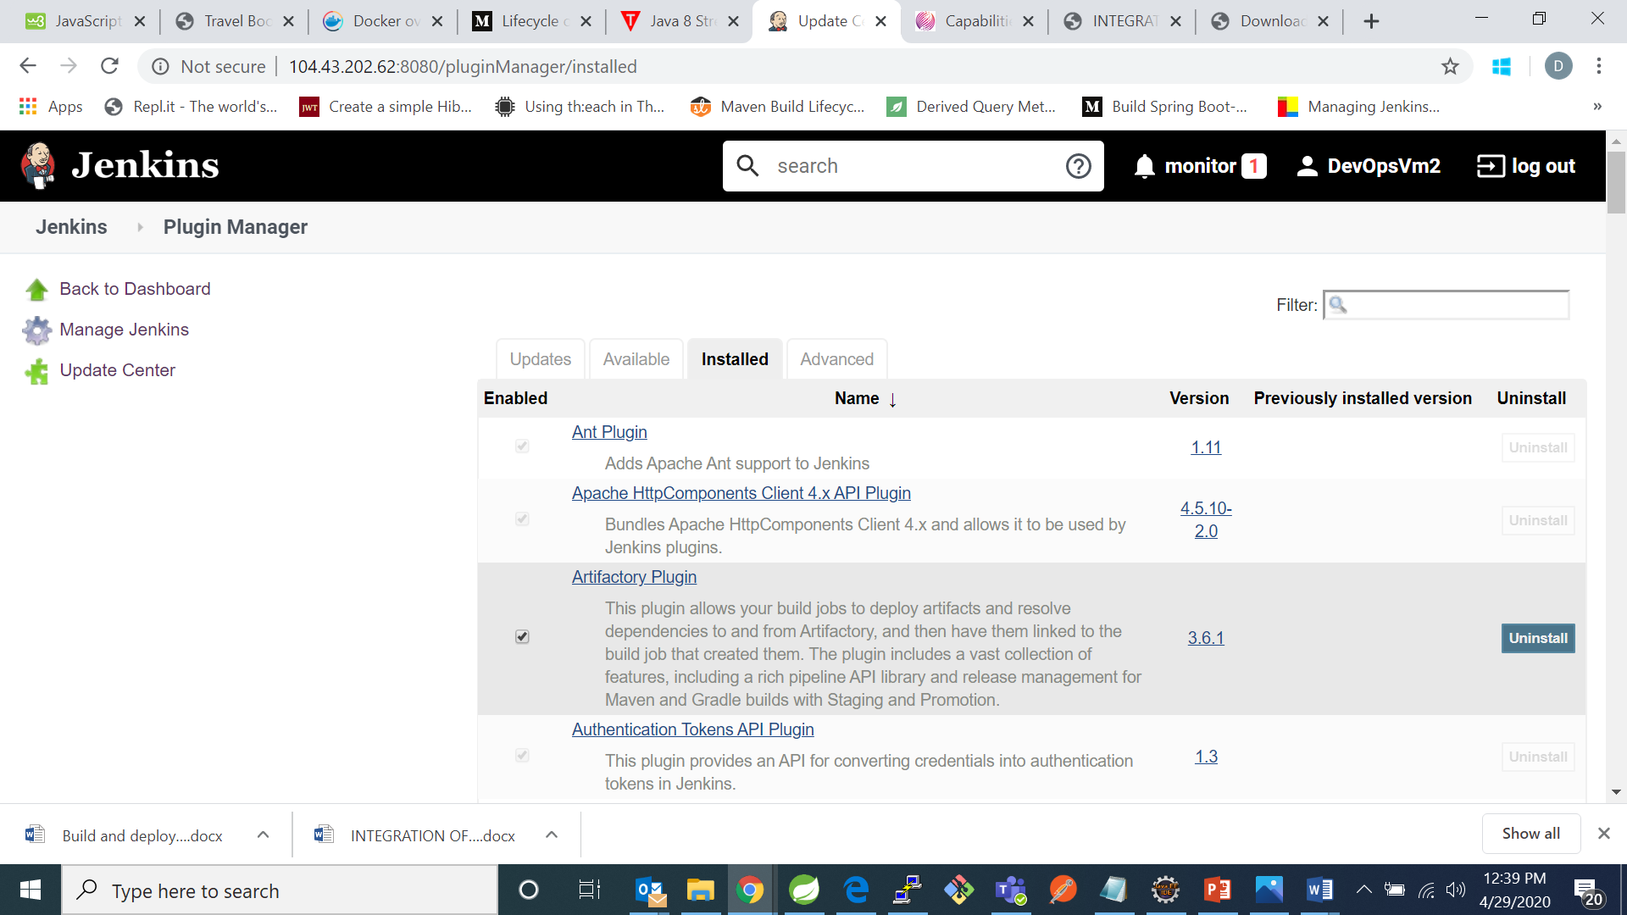

* In the next step go back to jenkins home and click on new item and give project name and select maven project and click on ok as shown below

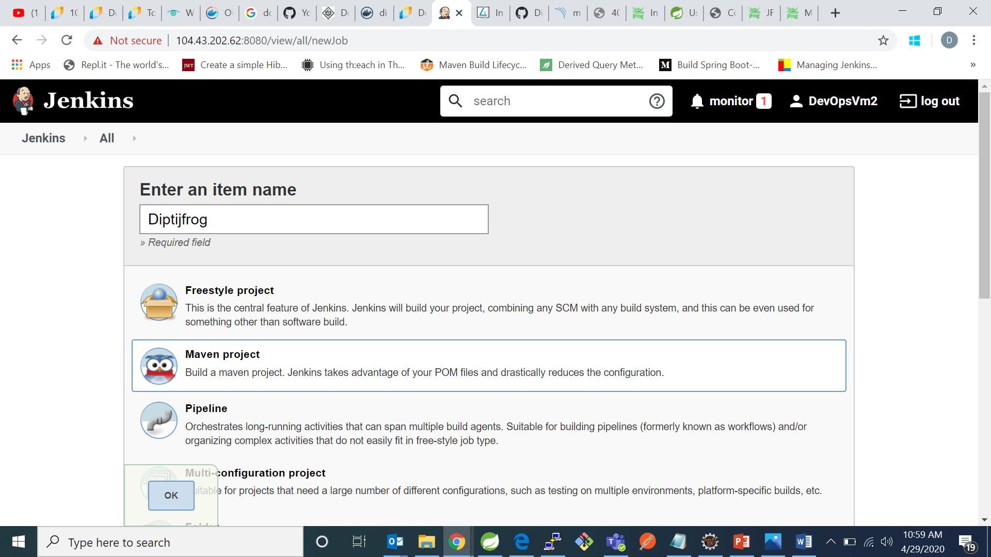

* After that you have to configures for your project like as follows by giving github url:

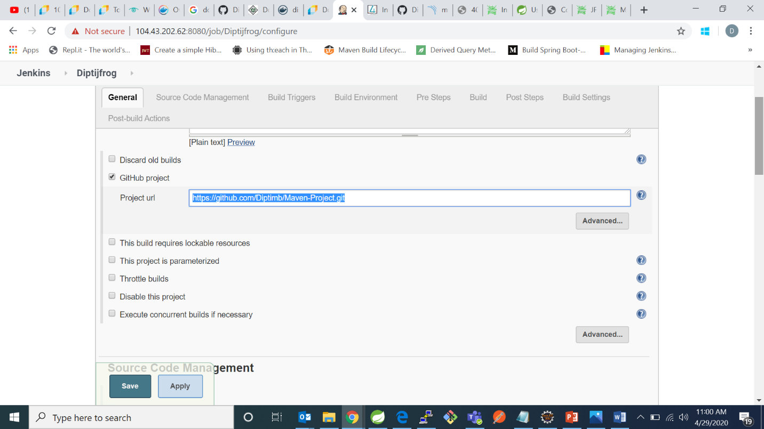

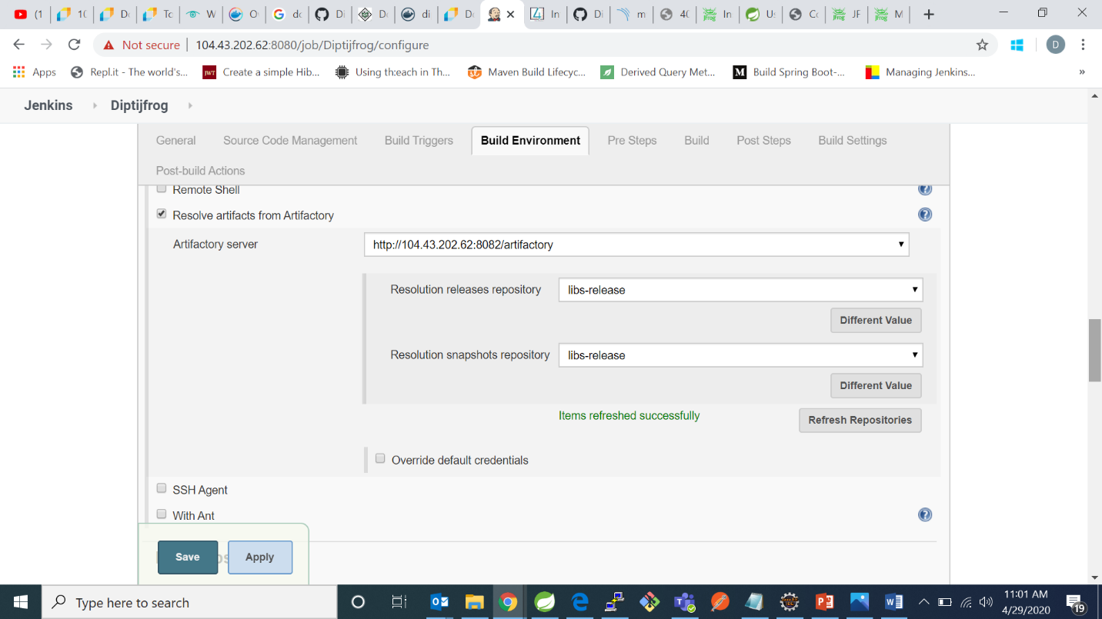

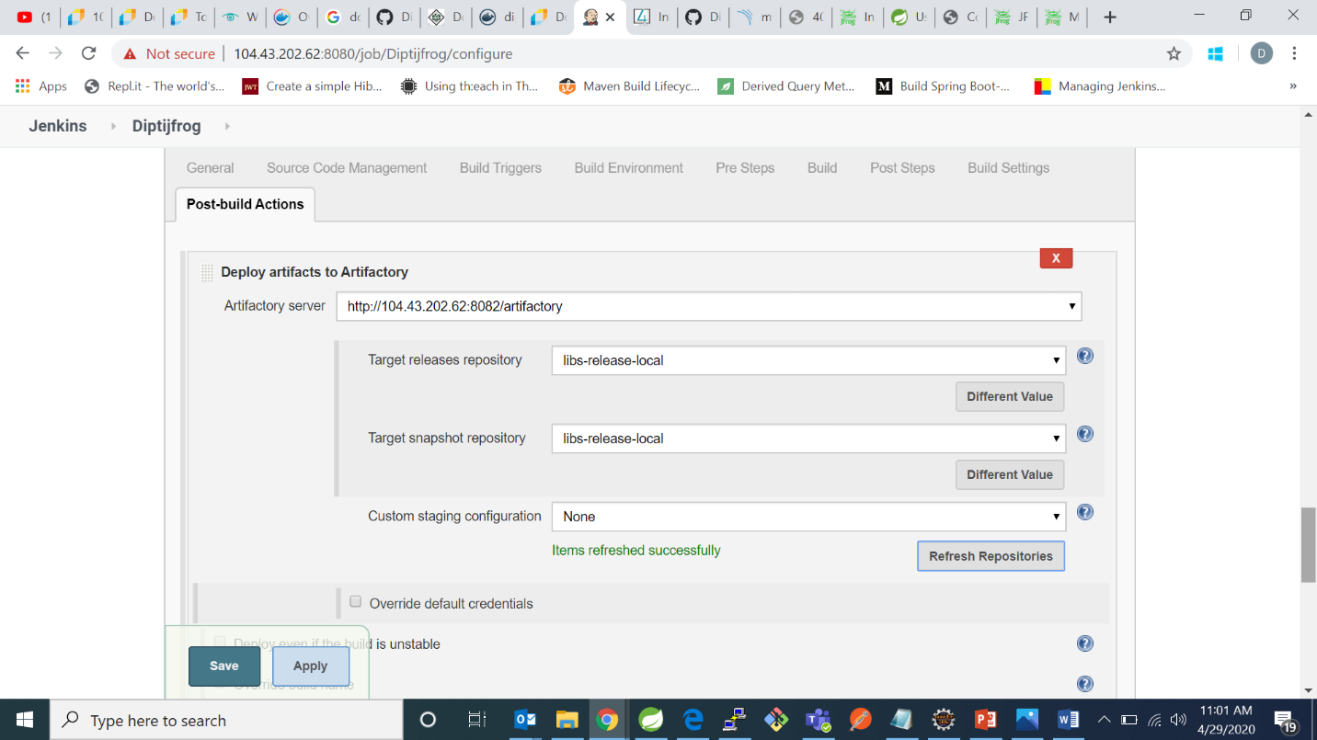

And click on save and after that click on build now.

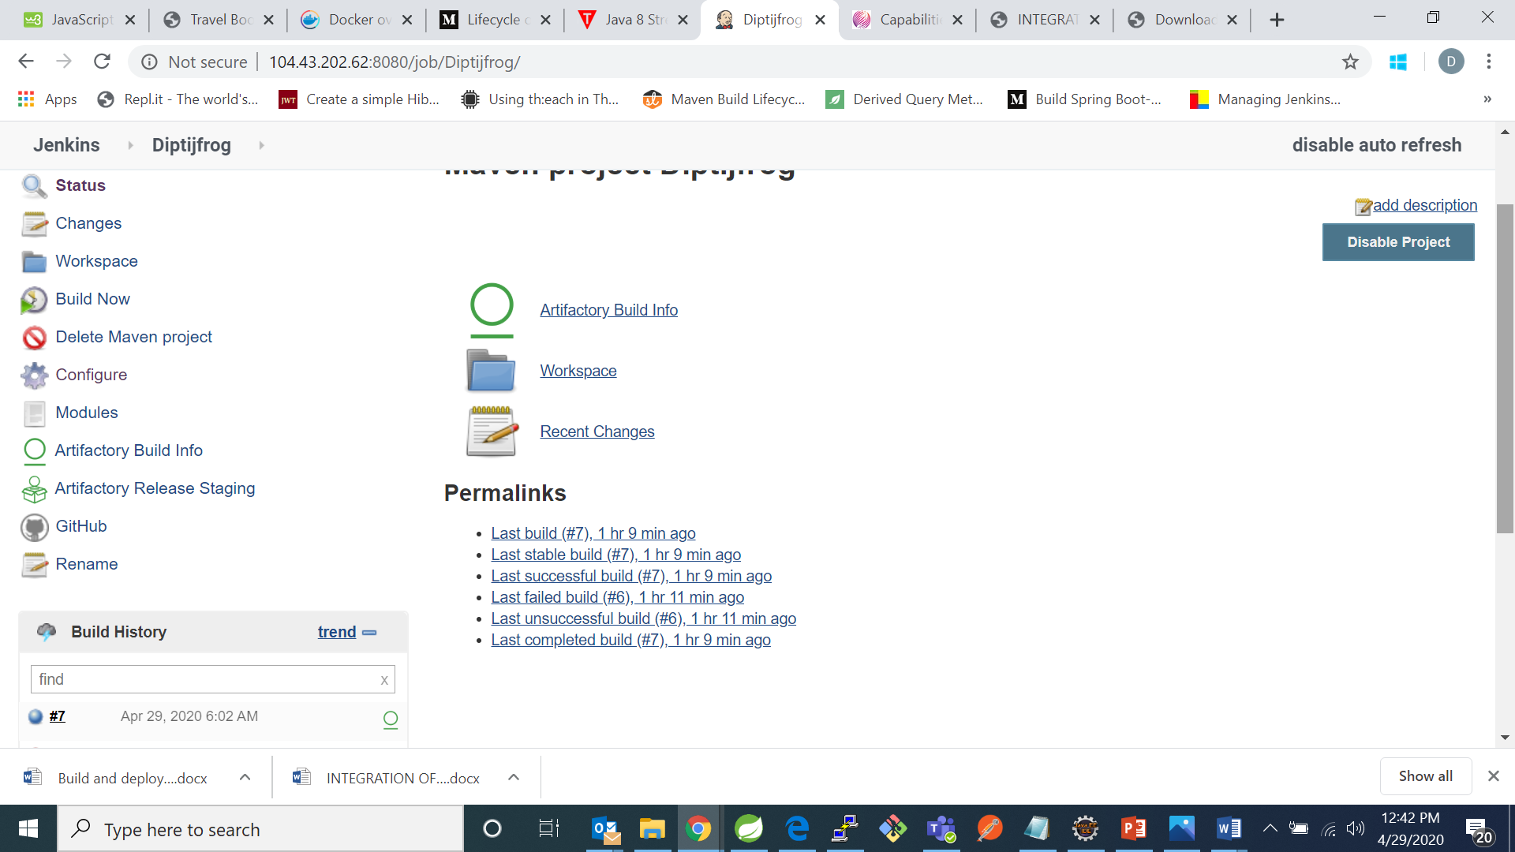

Now go to jfrog artifactory and check for your project in build section:

